Nom______________________________________________________________________________________
Quiz La Famille
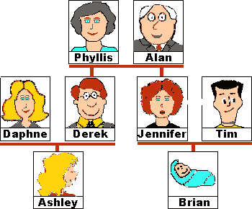

MOI

grand-père père oncle soeur cousin
grand-mère mere tante frère cousine

Write the relationship to "Moi" next to each name:

- Jennifer ______________________

- Brian ______________________

- Phyllis ______________________

- Daphne ______________________

- Tim ______________________

- Alan ______________________

- Ashley ______________________

- Derek ______________________

